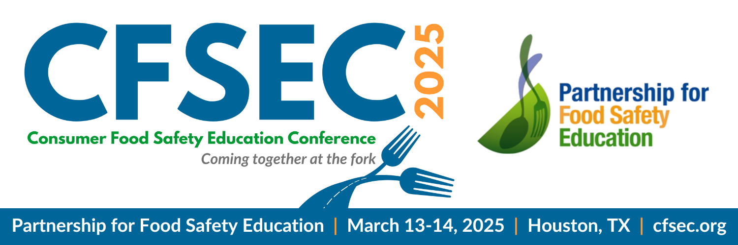

Attendee & Speaker
Promo Toolkit
This toolkit will help you quickly and easily tell
your colleagues that you’re attending the
conference and invite them to join you.

Social Media Posts
Post 1: Event Announcement
📅 Mark your calendars! The 2025 Consumer Food Safety Education Conference is happening March 13-14, 2025, at Sysco Headquarters in Houston, TX! 🎉 Join leading food safety experts for two days of interactive discussions, networking, and essential tools to elevate food safety practices. Don’t miss the only U.S. conference dedicated exclusively to food safety education! Register today for an early bird discount: https://cfsec.org/register/ #CFSEC2025 #FoodSafetyEducation
Post 2: Why Attend?
🚨 Why attend the 2025 Consumer Food Safety Education Conference? It’s the ONLY event in the U.S. focused entirely on food safety education. This interactive, two-day conference will equip you with new insights, industry connections, and practical tools to improve food safety practices. Plus, you’ll earn CEUs! 🌟 Register now for an early bird discount: https://cfsec.org/register/ #CFSEC2025 #FoodSafetyEducation #CEUOpportunities
Post 3: Highlight Networking Opportunities
🌟 Connect with food safety leaders and professionals from across the industry at the 2025 Consumer Food Safety Education Conference! 🤝 Join us in Houston, TX, March 13-14, 2025, to build connections that will help you elevate your food safety practices. Be part of the discussion on the future of food safety! Register here for an early bird discount: https://cfsec.org/register/ #CFSEC2025 #FoodSafetyEducation
Post 4: Earn CEUs
🎓 Enhance your expertise and earn CEUs at the 2025 Consumer Food Safety Education Conference, March 13-14 in Houston, TX! 💡 This unique event offers a platform to engage with innovative food safety leaders and leave with practical tools to make a real-world impact. Don’t miss out! Learn more and register today for an early bird discount: https://cfsec.org/register/ #EarnCEUs #CFSEC2025 #FoodSafetyEducation
Post 5: CFSEC Early Bird Discount Registration
🚨 Don't wait! Register early for the 2025 Consumer Food Safety Education Conference and SAVE with our early bird discount! 🌟 This two-day interactive event in Houston, TX, will equip you with the tools and resources to elevate food safety practices while earning CEUs. Early bird offer ends Tuesday, Dec. 31. Register today: https://cfsec.org/register/ #EarlyBirdSavings #CFSEC2025 #FoodSafetyEducation
Post 6: Last Call for Early Bird Discount
⏳ Last chance to register for the 2025 Consumer Food Safety Education Conference at a discounted rate! Early bird pricing ends Tuesday, Dec. 31, so act fast and save! Don’t miss out on two days of networking, discussions, and hands-on food safety tools. Sign up now: https://cfsec.org/register/ #CFSEC2025 #FoodSafetyEducation #EarlyBirdSavings

Newsletter Article

Don’t Miss the 2025 Consumer Food Safety Education Conference
Early Bird Registration Ends December. 31
The 2025 Consumer Food Safety Education Conference will take place on March 13-14, 2025, at Sysco Headquarters in Houston, Texas. As the only U.S. conference dedicated exclusively to food safety education, this event is not to be missed!
This interactive two-day event will feature forward-thinking food safety leaders and provide attendees with the opportunity to engage in dynamic discussions on the future of food safety. In addition to networking with notable industry professionals, you’ll also gain access to the latest tools and resources designed to enhance food safety practices.
Register by Tuesday, Dec. 31 to take advantage of the early-bird discount and secure your spot at a lower rate. This interactive two-day event will bring together forward-thinking food safety leaders and provide opportunities for networking, dynamic discussions, and the latest tools to enhance food safety practices. Plus, attendees will earn Continuing Education Units (CEUs) while gaining valuable insights to apply in the real world.
Don’t miss your chance to save on registration! Register today at https://cfsec.org/register/ and be part of the conversation on the future of food safety. Early bird pricing ends soon, so act fast!
For more information, visit https://cfsec.org or contact the Partnership for Food Safety Education at cfsec@fightbac.org.

Events Calendar
Save the Date: Consumer Food Safety Education Conference
📆 Date: March 13-14, 2025
📍 Location: Sysco Headquarters, Houston, Texas
🔗 Register: https://cfsec.org/register/
📆 Click to add this event to your Google calendar!
📆 Click to add this event to your Outlook calendar!
Don’t miss the 2025 Consumer Food Safety Education Conference, the only U.S. event dedicated exclusively to food safety education! This interactive two-day conference will bring together forward-thinking food safety leaders for engaging discussions, invaluable networking opportunities, and access to the latest tools to enhance food safety practices.
Attendees will also have the chance to earn continuing education units (CEUs) and leave with actionable insights to drive improvements in food safety.
Don’t miss out on this important event — register by Tuesday, Dec. 31, to take advantage of our early bird discount!

